Table of Contents
Table of Contents 1
List of Figures 1
List of Tables 1
Heading 1 1
Tables 1
Heading 2 2
Images 2
Referencing 2
Heading 3 3
Equations 3
Header and Footer 3
Appendix A 4
References 5

List of Figures
Figure 1: Sample Picture 2
Figure 2: Sample Plot with curve 3

List of Tables
Table 1: Sample Table 1

Heading 1
Use this type of heading for Level 1 subsections. For normal text like this one use the Normal style. Leave only one line between paragraphs. Do NOT indent. Be sure to format your text by using the styles specified in this template.

Heading 2
Use this heading for Level 2 subsections

Heading 3
Use this heading for Level 3 subsections.

Heading 4
Use this heading for Level 4 subsections.

Heading 5
Use this heading for Level 5 subsections.

Table of Contents and Lists
The Table of Contents, List of Figures, and List of Tables are automatically created by the word processor. Whenever you add a header with any of the heading styles shown above, or when a caption is added to a figure or table you must go to the section containing the table of contents and the lists, and update them by right-clicking and selecting Update from the drop-down menu.

Tables
If you want to include a table either create the table within Microsoft Word ® or copy and paste it from Microsoft Excel ®. You are free to draw the borders of the table as you please, but avoid messy layouts. All tables must be captioned above and referenced within the text: … as seen in Table 1. To caption use Insert -> Reference -> Cross-reference -> Table. Select only label and number. You should leave a single space between the table and the next line or the next table/figure

Table 1: Sample Table
 | Metric A | Metric B
Element 1 | 1 | 5
Element 2 | 2 | 6
Element 3 | 3 | 7
Element 4 | 4 | 8

Images
You will need to include images, tables and equations for this report. To insert an image preferably use JPG, GIFF and PNG files and small BMP (bitmap) files, otherwise the size of your file will be too big. When inserting an image make sure it is centered. There must be a caption for all images. Use Insert-> Reference -> Caption -> Figure. The caption must be below the image. It is important that you reference your images within the text, and that you use Insert -> Reference -> Cross-reference -> Figure. Select only label and number. For example you say: … as shown in Figure 1.

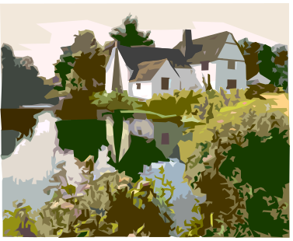
Figure 1: Sample Picture

Referencing
You should reference all your sources and any work that is not your own. Your references should follow formatting rules for a standard technical publications and be presented in alphabetical order in the References section at the end. The numbering of your sources should follow the alphabetical order of the list. To ease this formatting you may use Endnote © which is available to all students. Follow software instructions to correctly insert and number the references.

If and image, plot or table presented is not made by the author of the report it must be properly referenced to the source in the body of the text. For example: … as shown in Figure 2 [1].
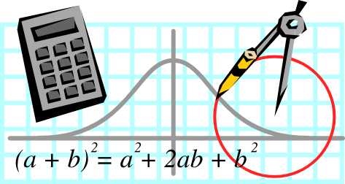
Figure 2: Sample Plot with curve

Equations
If you need to insert an equation use the Equation Editor built into Microsoft Word. The equation should be centered and captioned. Do NOT name the equations, just leave the number. However you must reference the equations in the body of the text. For example: “this relationship is given by the expression in Equation 1.” To insert the reference number use Insert -> Reference -> Cross-reference -> Equation.

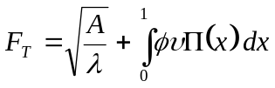
Equation 1

Header and Footer
Insert the project name and student or team name in the header. To change the header go to View → Header and Footer. The footer should only include the page number as it appears in this template. Notice that the first section uses roman numerals and the rest uses standard numeration.

Appendix A
Every appendix should start in a new page. To add appendices use Heading 1 for the title and use page break.

References

- Doe, J., Sample Book Name Here: a Practical Approach and Important Theory, 3rd Ed. Mockingbird Publications, Atlanta, 2003.

